-----------------------------Compiled with riscduino board ----------------------------

WARNING: library LiquidCrystal I2C claims to run on avr architecture(s) and may be incompatible with your current board which runs on riscv architecture(s).

c:/users/hp/appdata/local/arduino15/packages/riscduino/tools/riscv64-unknown-elf-gcc/1.0.1/bin/../lib/gcc/riscv64-unknown-elf/10.1.0/../../../../riscv64-unknown-elf/bin/ld.exe: C:\Users\HP\AppData\Local\Temp\arduino\sketches\F98344D5FDB09CA76918C5064AFB0AE9\sketch\smart_db_02.ino.cpp.o: in function `.L0 ':

C:\Users\HP\Desktop\smart_db_02/smart_db_02.ino:118: undefined reference to `__dso_handle'

c:/users/hp/appdata/local/arduino15/packages/riscduino/tools/riscv64-unknown-elf-gcc/1.0.1/bin/../lib/gcc/riscv64-unknown-elf/10.1.0/../../../../riscv64-unknown-elf/bin/ld.exe: C:\Users\HP\AppData\Local\Temp\arduino\sketches\F98344D5FDB09CA76918C5064AFB0AE9\sketch\smart_db_02.ino.cpp.o: in function `__static_initialization_and_destruction_0':

C:\Users\HP\Desktop\smart_db_02/smart_db_02.ino:120: undefined reference to `__dso_handle'

c:/users/hp/appdata/local/arduino15/packages/riscduino/tools/riscv64-unknown-elf-gcc/1.0.1/bin/../lib/gcc/riscv64-unknown-elf/10.1.0/../../../../riscv64-unknown-elf/bin/ld.exe: C:\Users\HP\AppData\Local\Temp\arduino\sketches\F98344D5FDB09CA76918C5064AFB0AE9/smart_db_02.ino.elf: hidden symbol `__dso_handle' isn't defined

c:/users/hp/appdata/local/arduino15/packages/riscduino/tools/riscv64-unknown-elf-gcc/1.0.1/bin/../lib/gcc/riscv64-unknown-elf/10.1.0/../../../../riscv64-unknown-elf/bin/ld.exe: final link failed: bad value

collect2.exe: error: ld returned 1 exit status

Multiple libraries were found for "Servo.h"

Used: C:\Users\HP\AppData\Local\Arduino15\packages\riscduino\hardware\riscv\1.2.6\libraries\SERVO

Not used: C:\Users\HP\Documents\Arduino\libraries\Servo

exit status 1

Compilation error: exit status 1

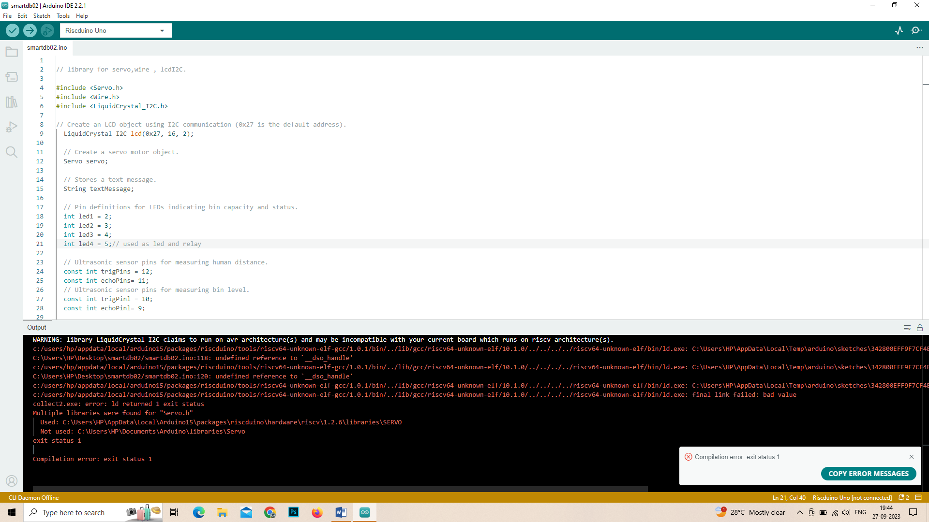

-----------------------------Compiled with Arduino board-------------------------------

Sketch uses 8454 bytes (26%) of program storage space. Maximum is 32256 bytes.

Global variables use 795 bytes (38%) of dynamic memory, leaving 1253 bytes for local variables. Maximum is 2048 bytes.

